Module Name:
Test Case ID: SD_TC_003
● Scenario ID: 1a
Scenario: open orang HRM
Test Steps: 1. Click to open
. screen sort

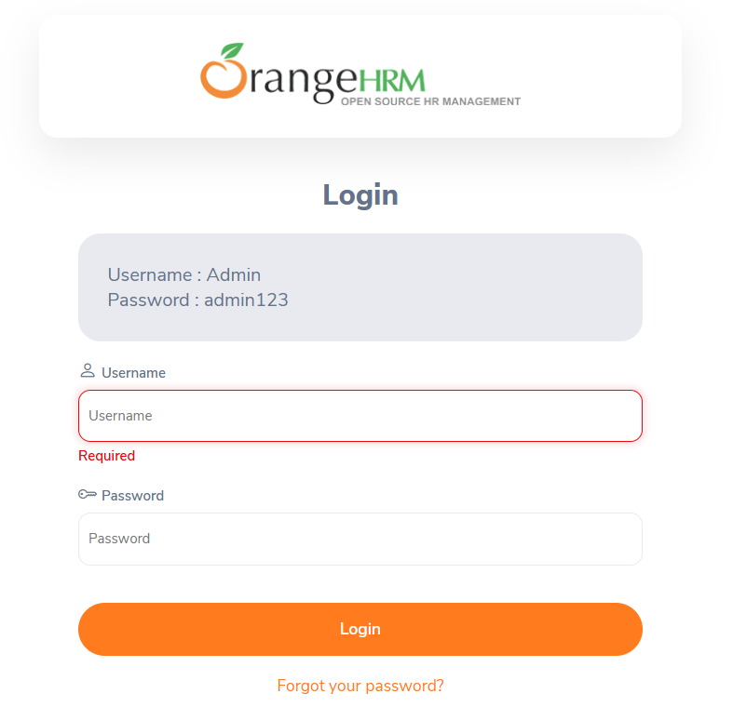

. scenario id 1b
login with wrong user name right password
test step
1 user name seth
2 password 123
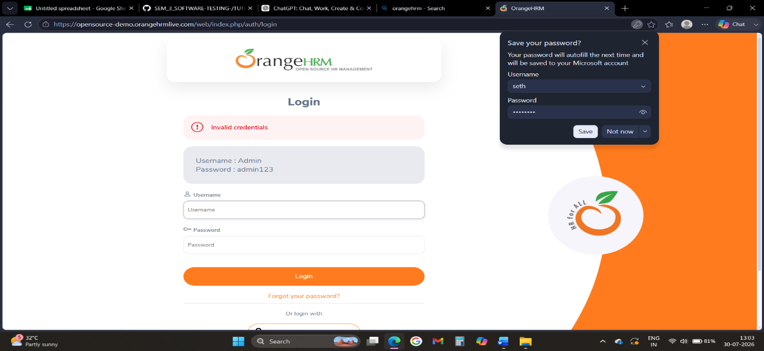
. scenario id:1c
Scenario: login with wrong password
Test step:
1. Ener valid user name
2. wrong password
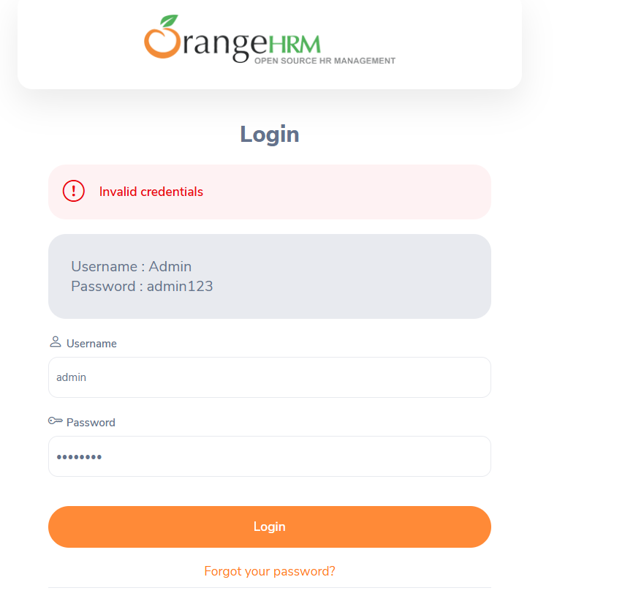
. scenario id:2a
Scenario: click to payment button
Test step:
1 tap to claim
Screen sort
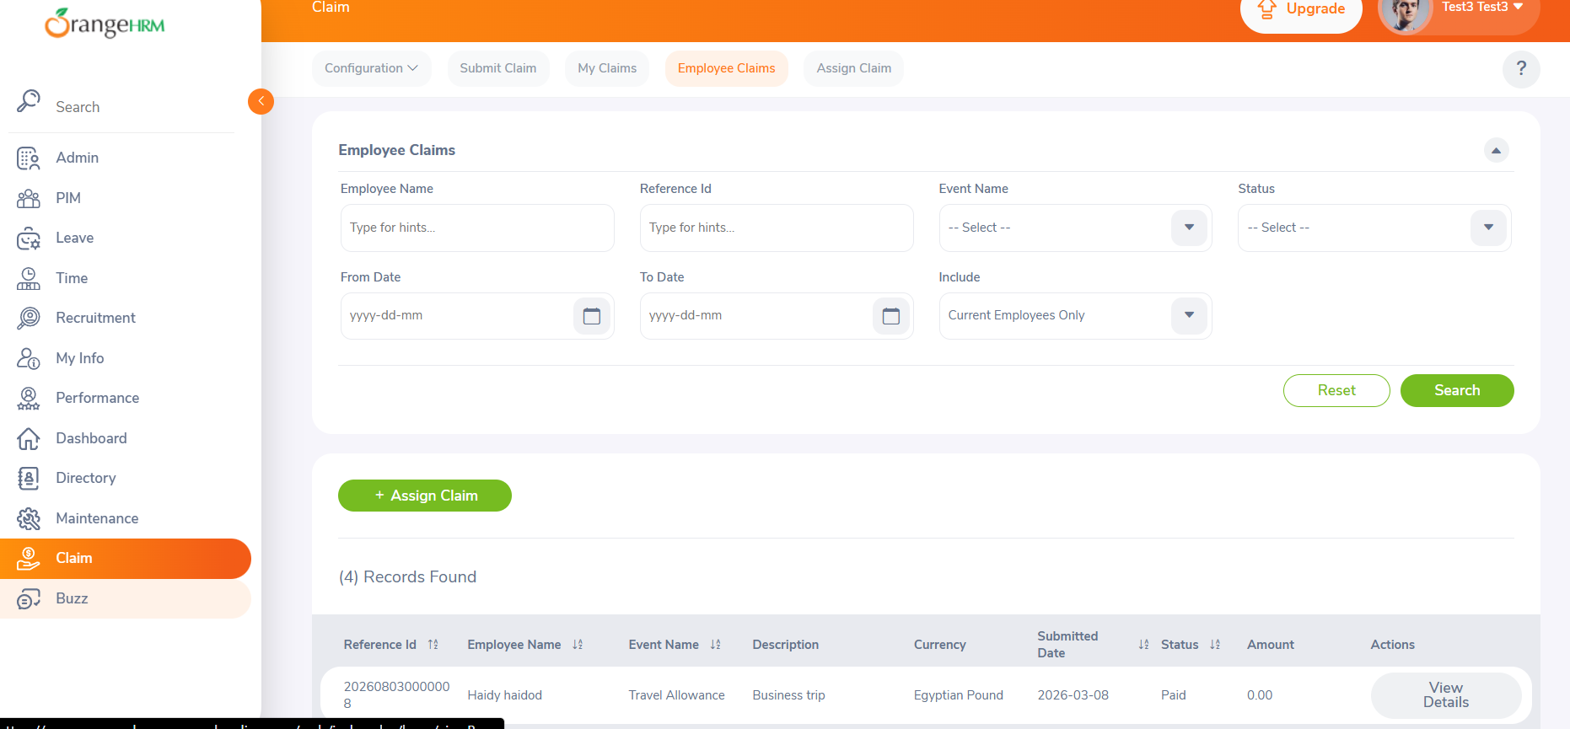

. scenario id:2b
Scenario: serch wrong name
Test step:
1 sherch kaka

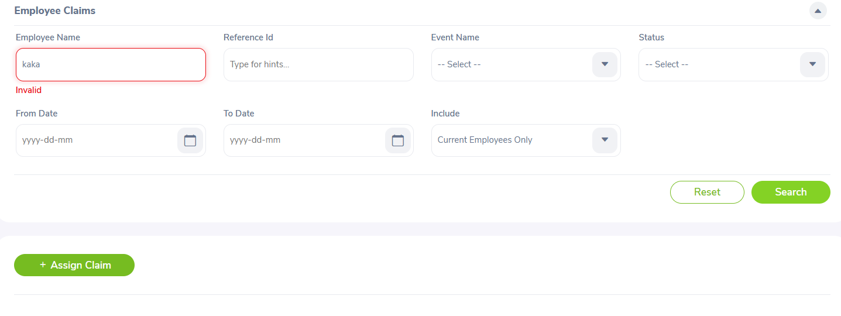
. scenario id:2c
Scenario: serch wrong name
Test step:
1 serch Haidy test haidod
Screen sort
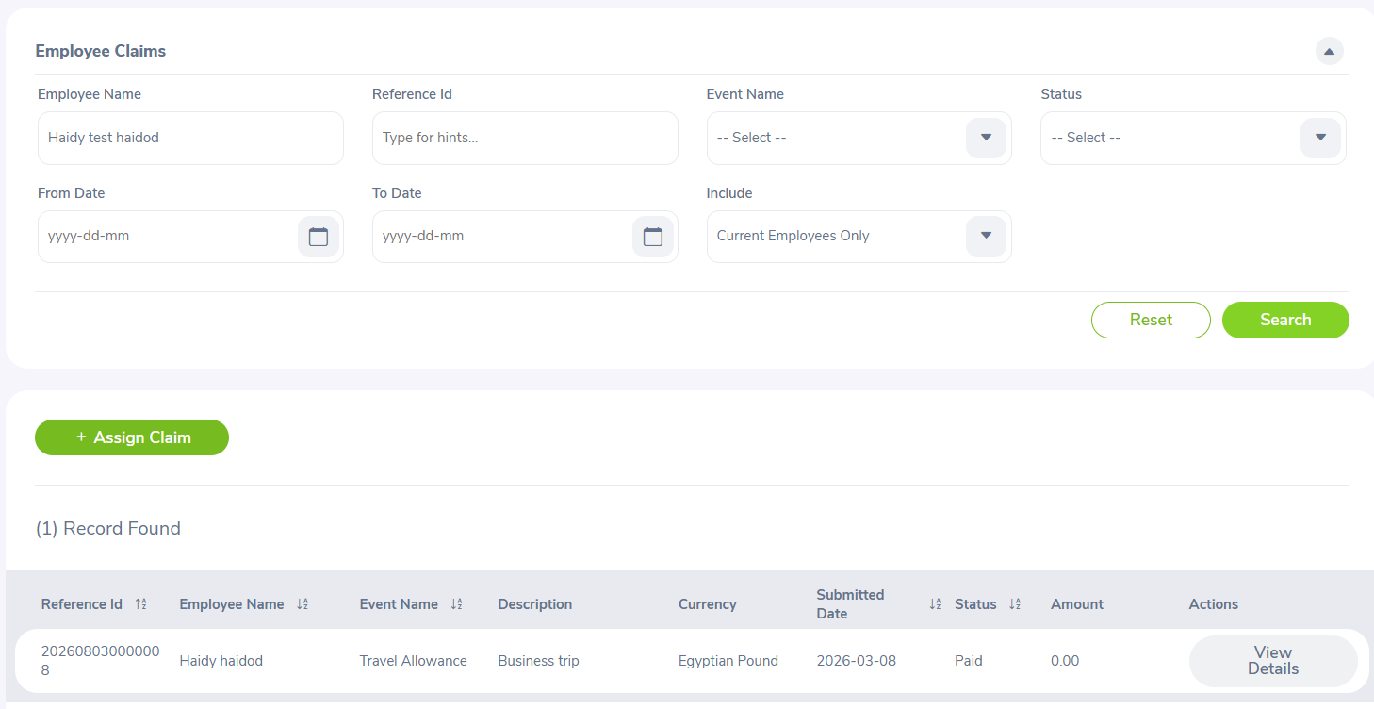
. scenario id:2d
Scenario: click to viwe datails
Test step:
1 click to viwe

Screen sort
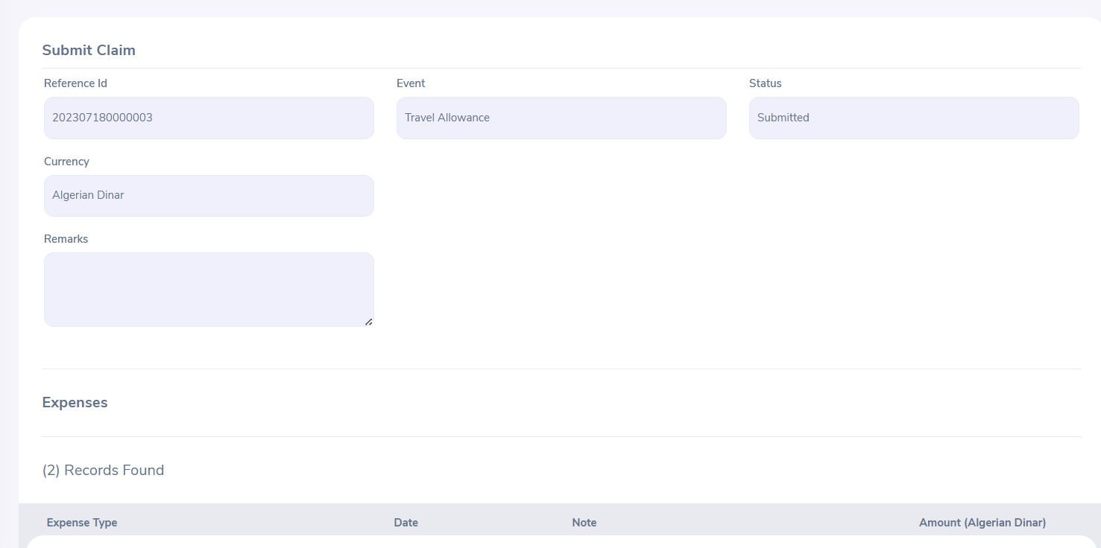

. scenario id:2e
Scenario: edit amount
Test step:
1 click to edit
Screen sort

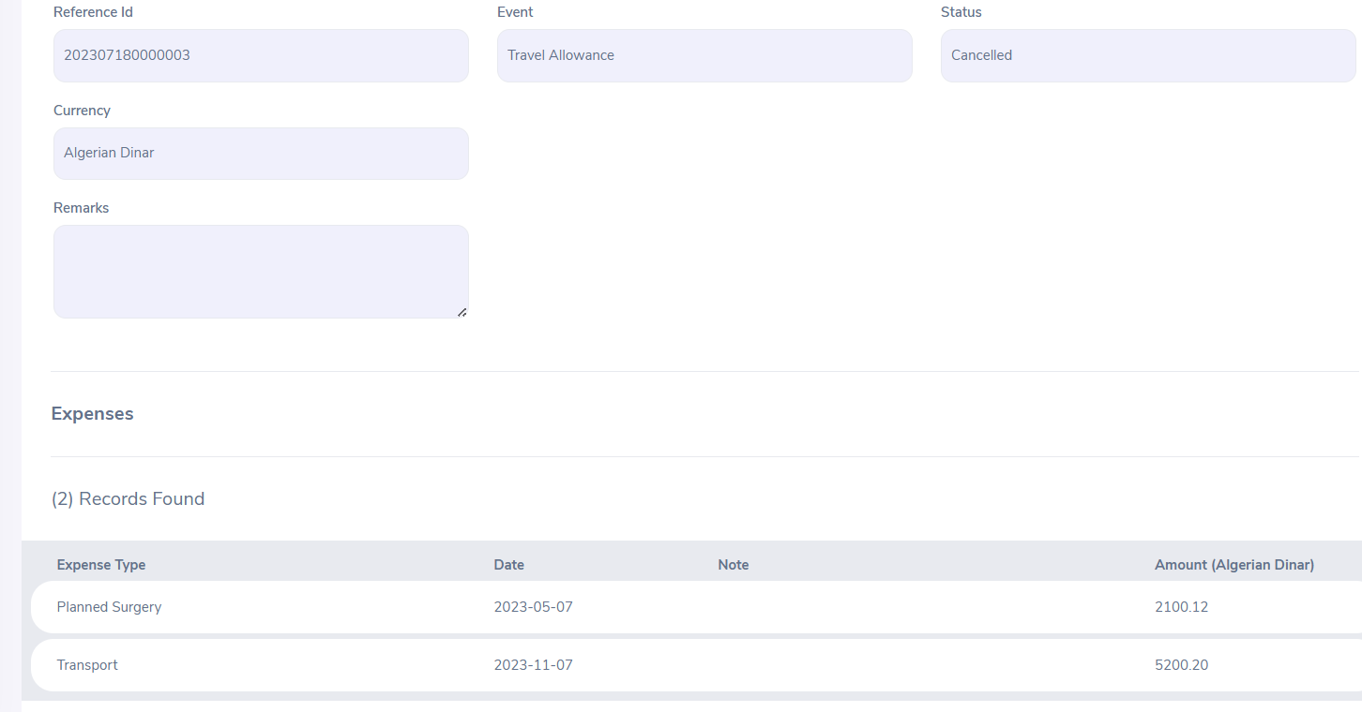
( there is no any edit button)

. scenario id:3a
Scenario: logout
Test step:
1 click to logout
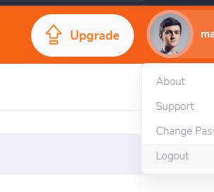
Screen sort

